# CAB230 Assignment Report.

## Nicholas Stolberg – n9731130

## Niall Stone – Insert Student Number

### Test in Firefox.

# Test Plan

## Accessing the Home Screen

When a user first accesses the home page, aka the search page, they should be presented with a multitude of things. The first is a header which provides the user with the ability to log in, register and account and view an example park.

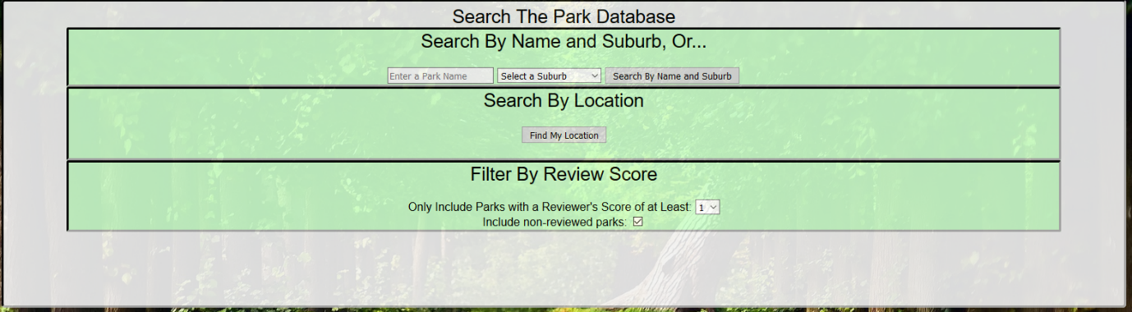The next part the page should present is all the options available to search for parks. This includes; name and suburb search, a search based on location and finally the ability to limit the search based on a parks individual average review score.

## Registering a New User.

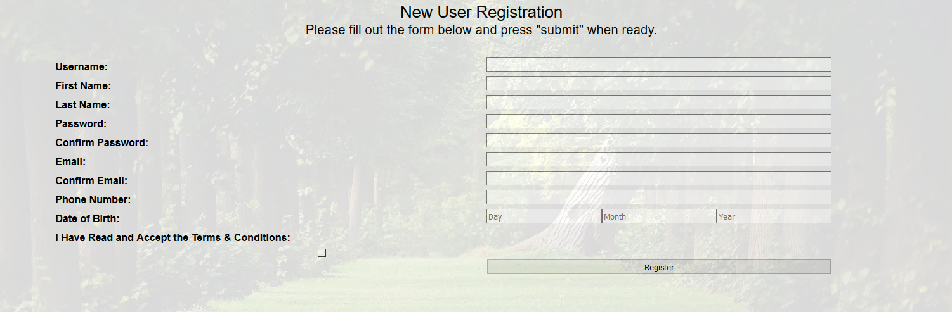The registration page will present to the user ten different input fields; Username, First Name, Last Name, Password, Confirm Password, Email, Confirm Email, Phone Number, Day, Month and Year to be used for Date of Birth and a checkbox to state that they accept the terms and conditions.

If the user was to click the submit button without filling in an input field they will be presented with red text informing them that that field must be filled. An example of this can be seen in the image bellow where none of the fields have been filled.

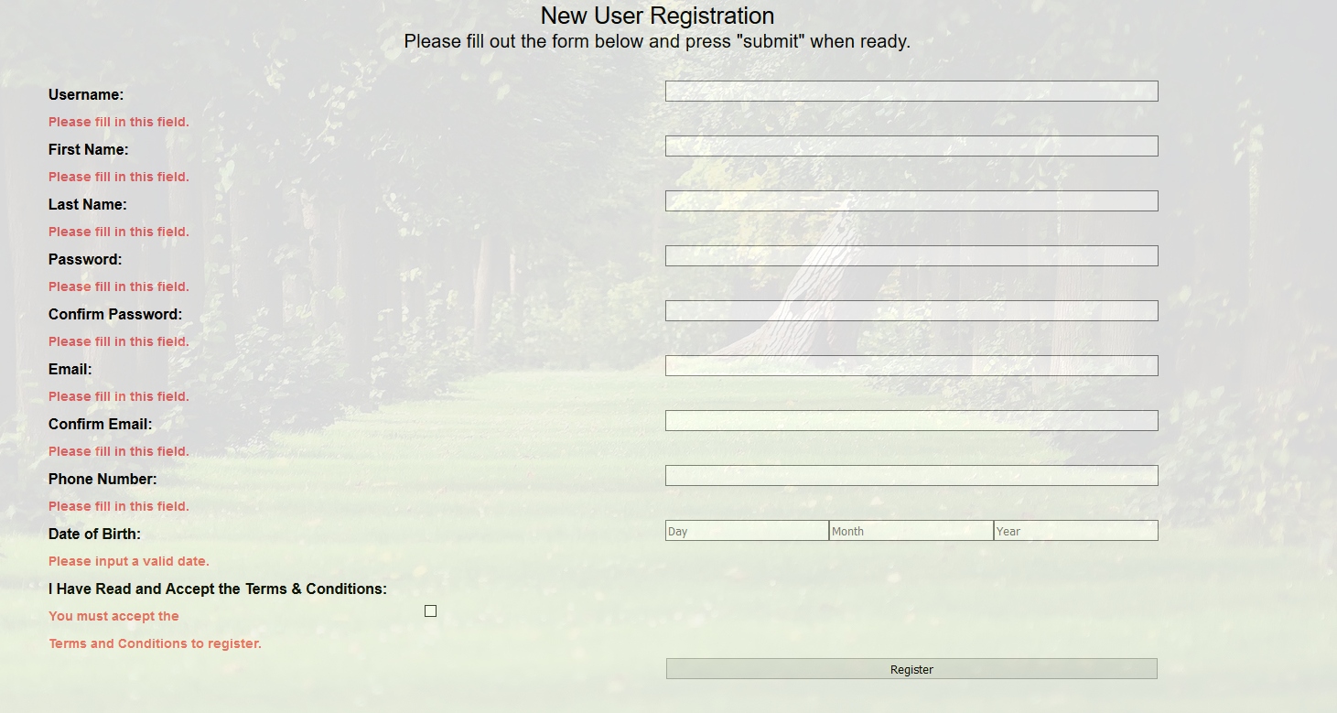

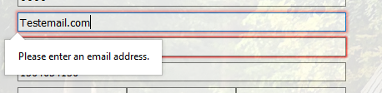Input fields such as password, Confirm Password, Email, Confirm Email and Date of Birth have further requirements when being filled in. If these requirements aren’t met then an account should not be made and the user informed why.







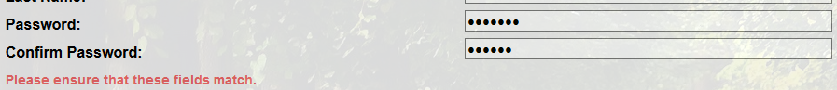



Finally if the username the user has chosen has already been taken the website should not create a new account and inform the user the name has been taken.

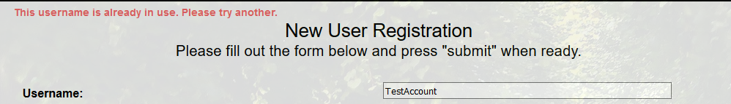

After all the input requirements have been satisfied the website should register the new account in the database and inform the user their account has been successfully made.



## Logging in as an Existing User.

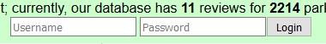If a user wishes to log into the website they will need to enter a valid username and password in the two input fields located at the top of the webpage.

The website should only allow users to log in if the username inputted into the text box matches with an account that exists in the database. As well as this the password inputted must match with the password stored in the database for the specified username. If the user fails to input a valid username of the correct password the system should not allow them to log in notify them that either their username of password is invalid.

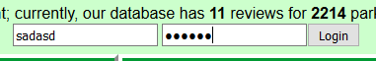

Invalid username and ID.

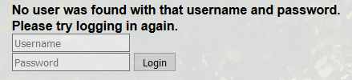

The user must remain logged in for the rest of their session on the website or until they click the log out button.

## Logging Out.

The log out button should be located at the top of every page on the website but only when the user is logged in should it be visible.

 If a user is to log out the top of the page should display the login input fields and the user must not be able to leave reviews for parks.



## Adding a Review.

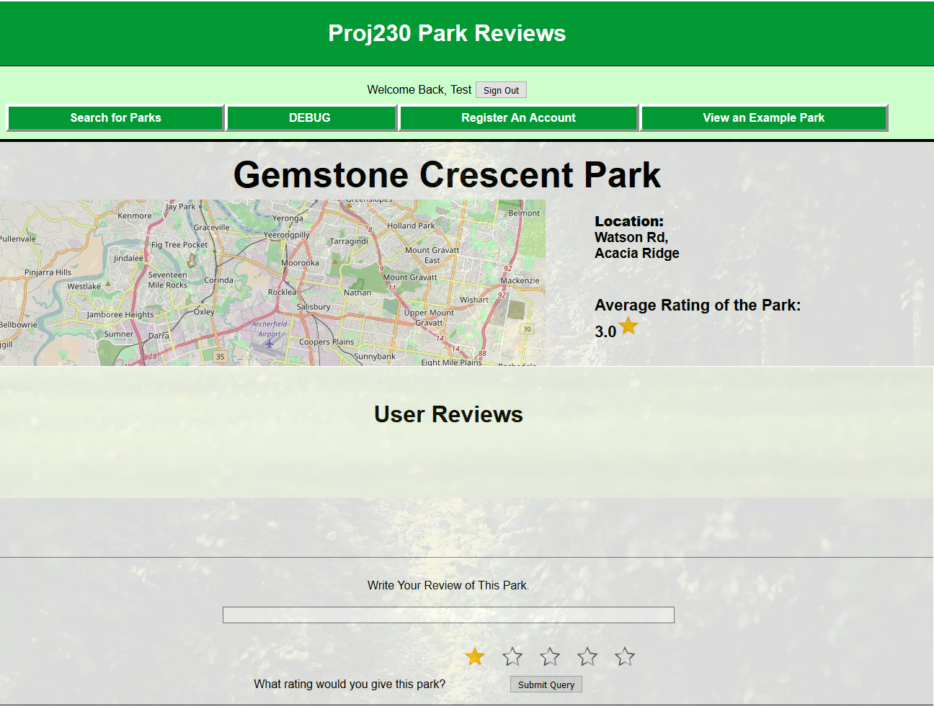Reviews must only be allowed to be made from a parks item page. If the user is not logged in they should not be able to create a review but should still be able to see already existing reviews. If a user is signed in the park’s page should present them with a text box to write their review, five stars so that the user can rate the park out of five and a submit button.

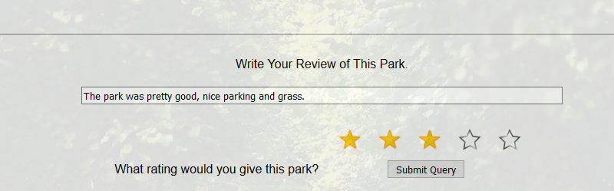After a user has written their review and clicked submit the page should now display the review at the bottom of the webpage and tell the user that they can’t write a review as they have already written one. A user should not be able to write more than one review per park.

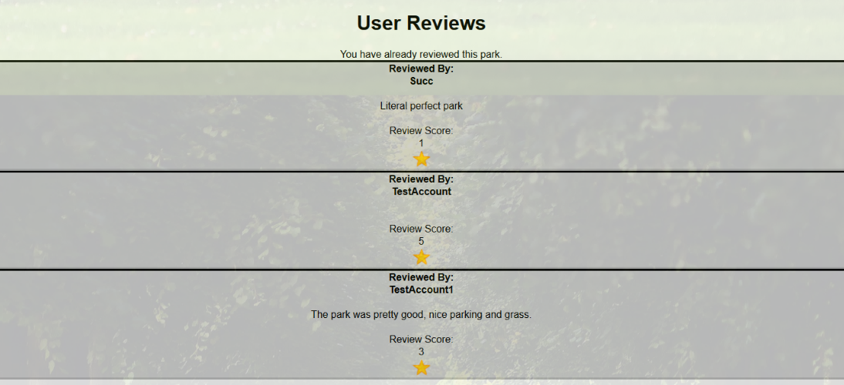

## Searching for an Item that Exists in the Database.

When a user opens the search page they should be presented with four different ways to filter their search. If the user searches purely by suburb they will always have a result returned to them, if however the user decides to search by park name they should only have results returned to them if a part or all of the parks name matches with the string the user chose as an input.

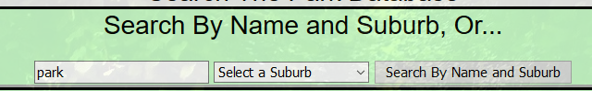

A search with the keyword park returns these results.

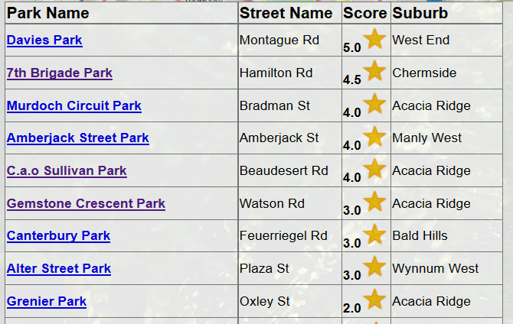

## Searching for an item that does not exist in the database.

When an attempt is made to search for an item that does not exist on the database the user should be taken to an empty version of the item results page. The website should not provide any form of error messages (i.e. 404 error) or crash if it searches for a non-existent item.

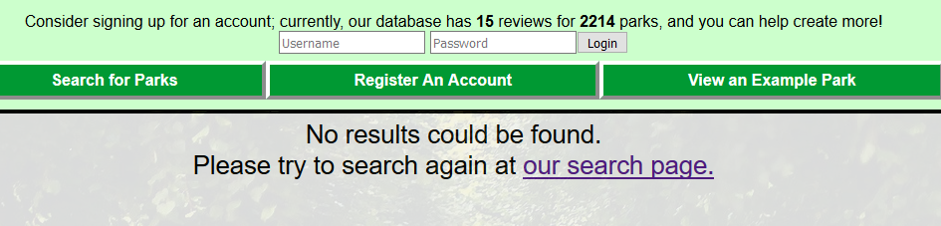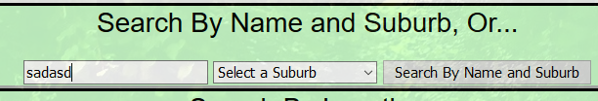

## Accessing and Individual Item Page.

When a user attempts to access an item’s individual page they should be presented with all the details of the park. This includes the park’s name, suburb and street, its average review score and an interactive map displaying the park’s location. As well as these the webpage should also display all the reviews made for the park and the input fields needed to leave a review if the user is logged in and has not left a review for that park yet.

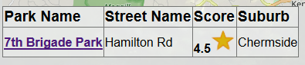

Navigate to and open 7th Brigade Park

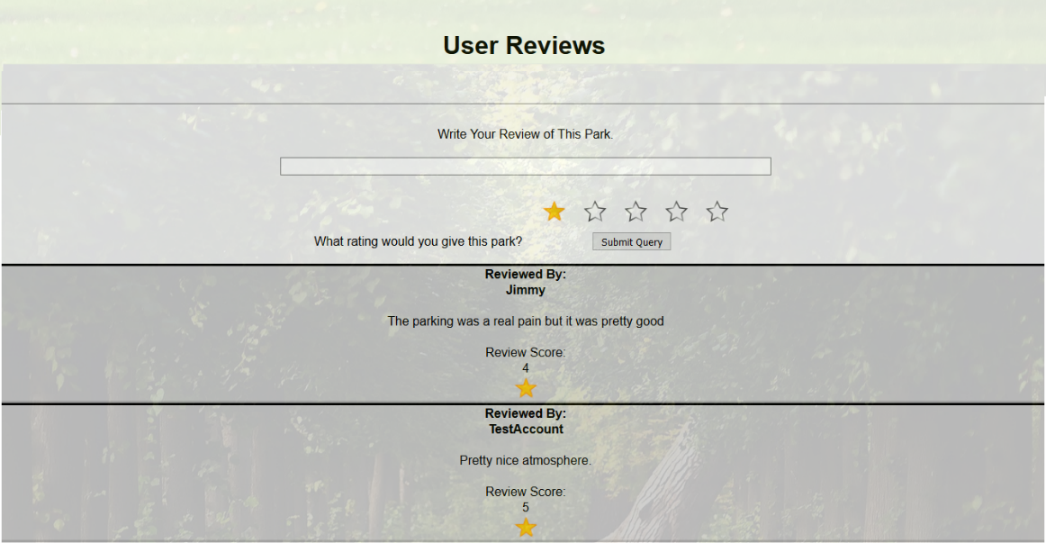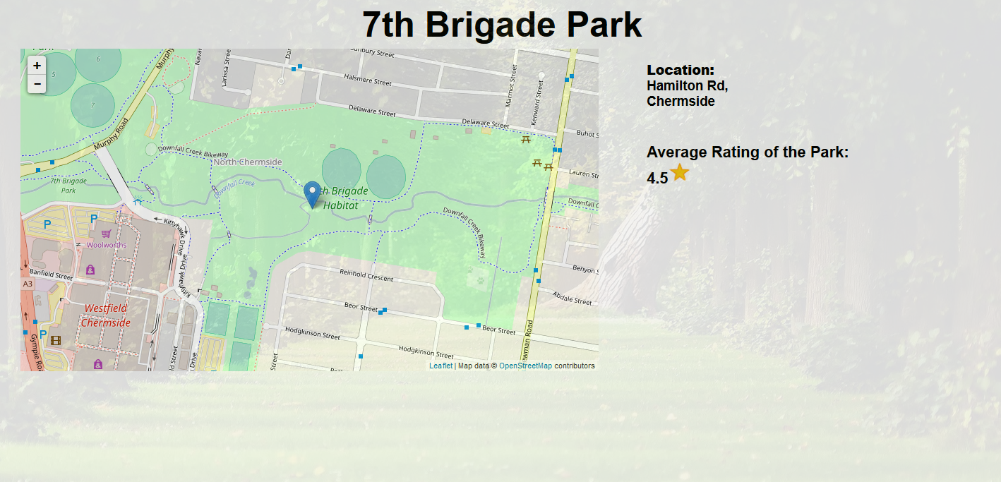

## Attempting to use a Cross Site Scripting attack but not being successful

## Attempting to use an SQL injection attack but not being successful

## Unregistered User not Being Able to Log In.

A use should not be able to log in if they do not have a valid username and password combination. If a user attempts to log in with either a wrong username or password they should not be registered as logged in and informed of the fact that the either the username or password they have inputted is wrong.

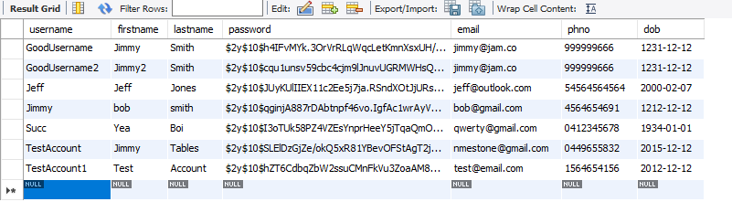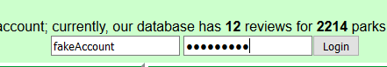

Currently registered accounts.

Login attempt made with username: fakeAccount and password: fakepass1

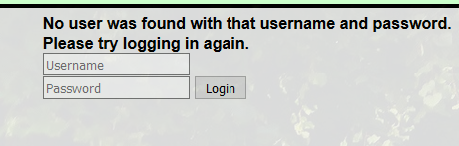

## Operating gracefully in multiple resolutions

The website should be able to operate under a multitude of different screen sizes, no matter what the size of the window is, none of the elements on the page should overlap with one another. (Examples of this on the next page.)

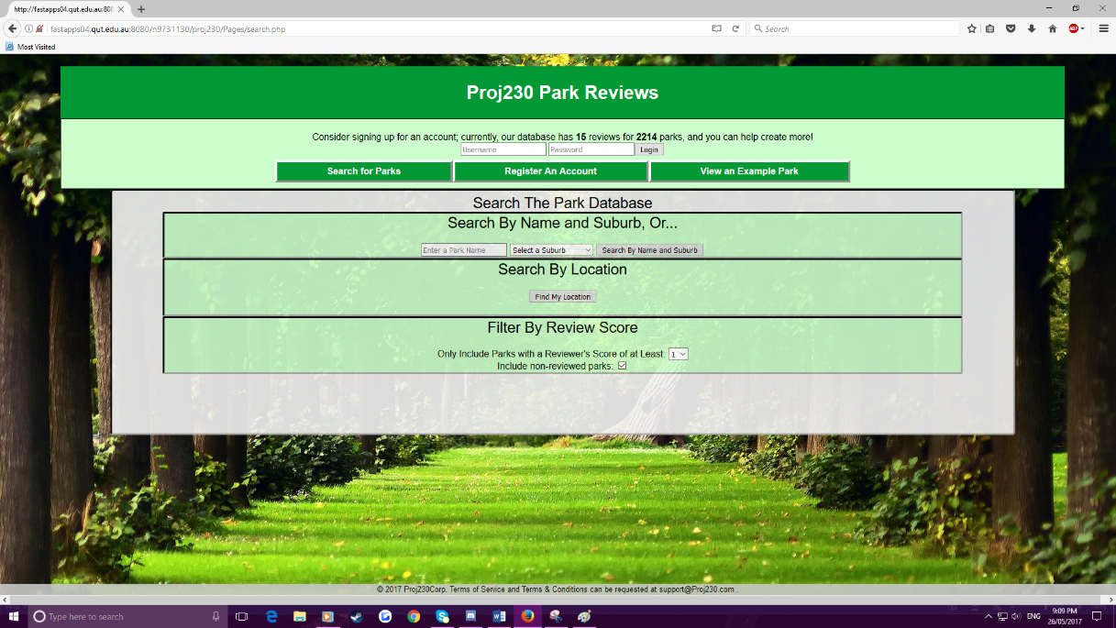 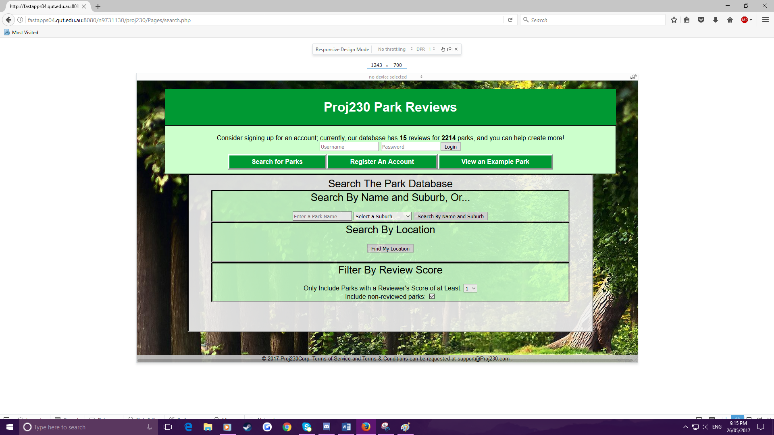 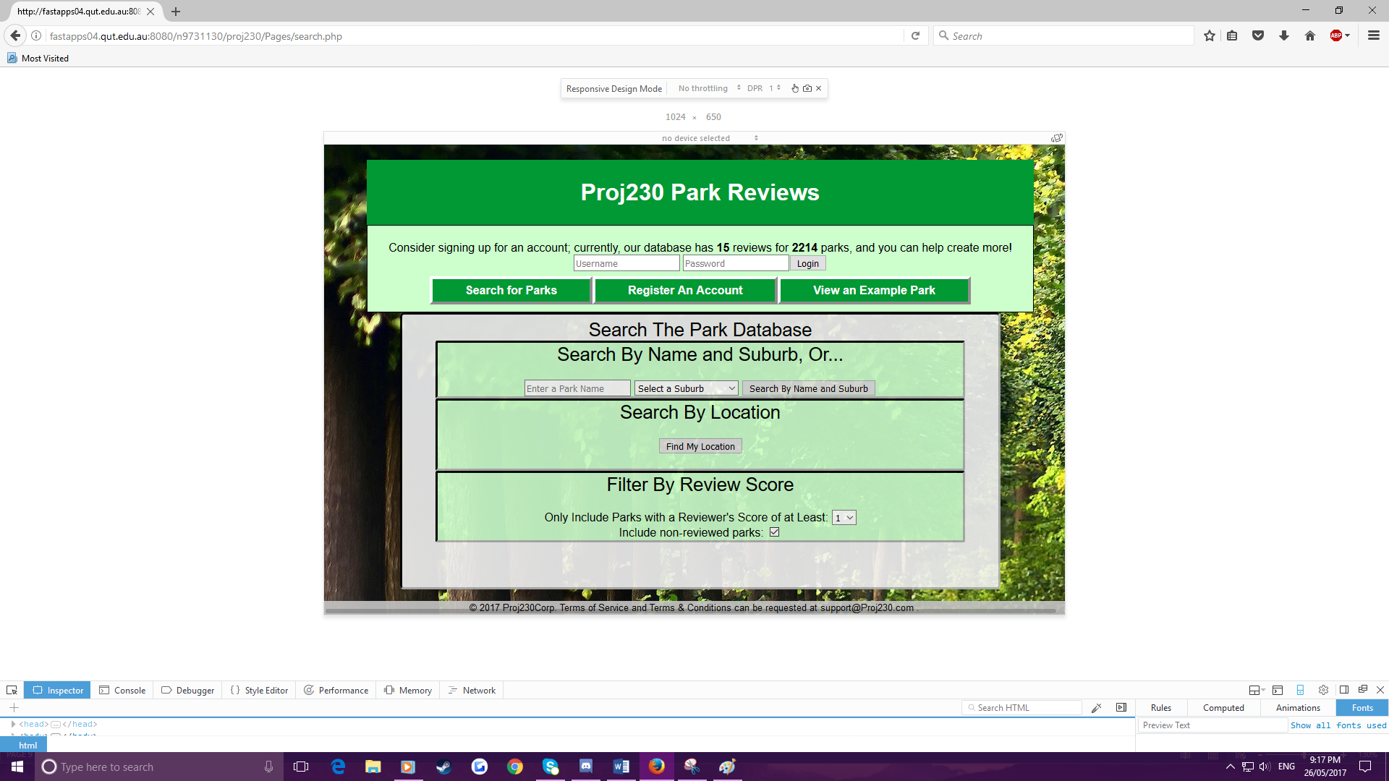

1024x650

1243x700

1920X1080

## SQL Query Example

This query is located in itemPage.php line 13.

## Map on Search Results Page.

After a search has been performed a map should appear above the search results table that provides markers that correspond to all of the results gained from the search. Clicking on these markers should take the user to that parks individual item page.

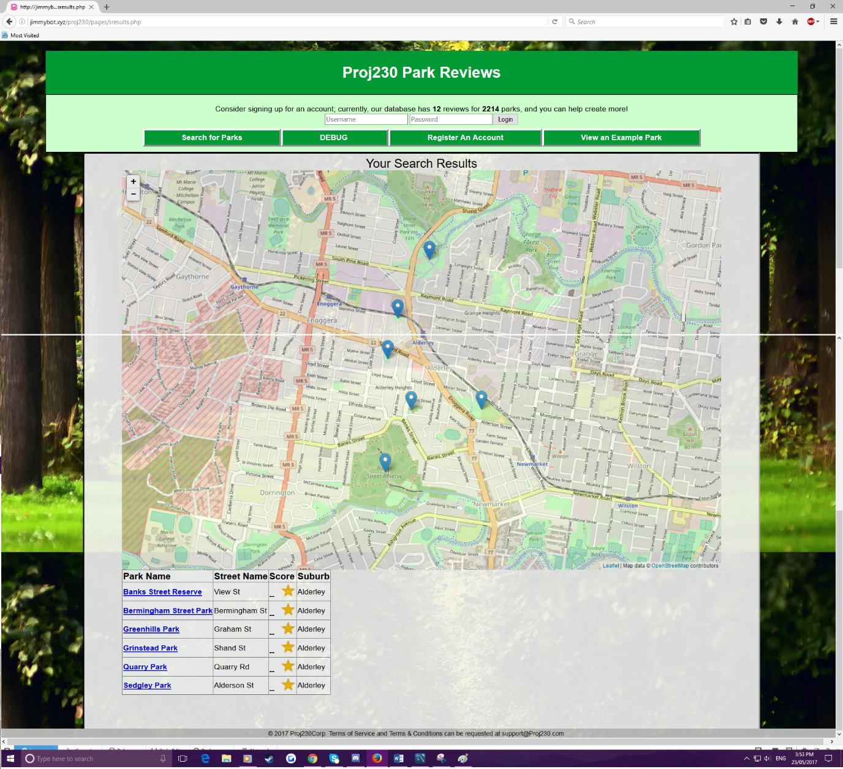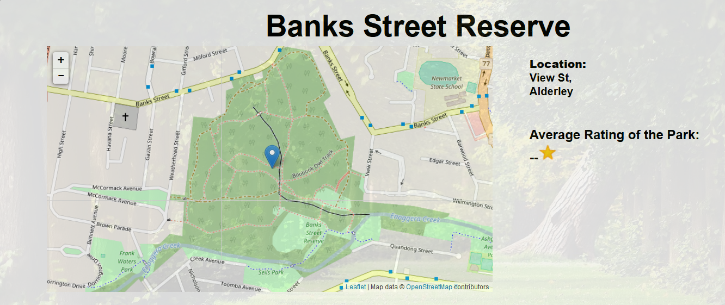

Clicked this one.

Item page results.

## Map on Item Page.

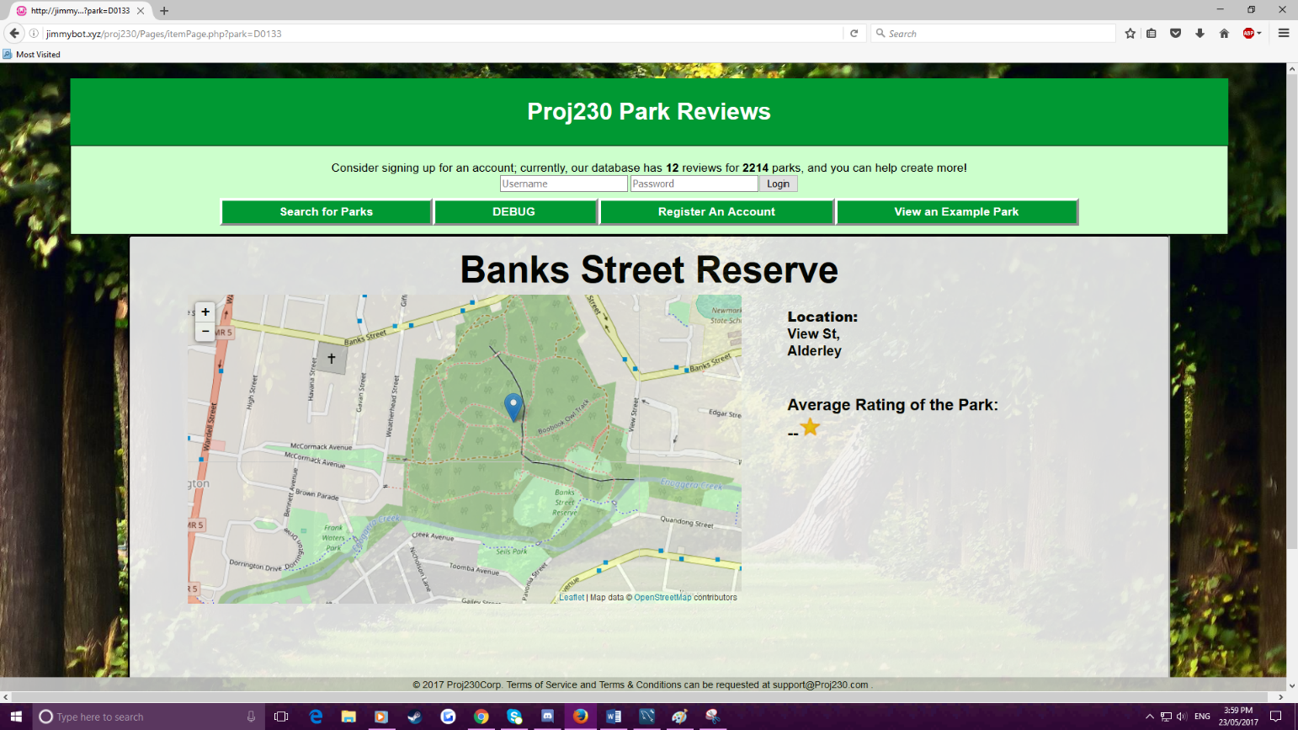A map should appear on a parks individual item page which is interactive and features a marker pointing out the parks location on said map.

Item page URL.

## Evidence that the geographic microdata is valid as reported by Google’s structured data validator.

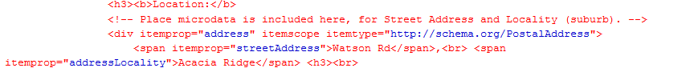

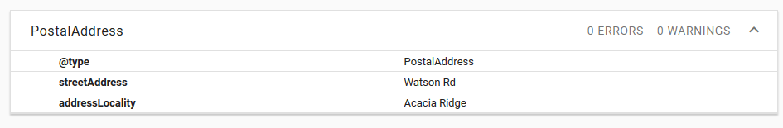

## Evidence that the microdata is valid as reported by Google’s structured data validator.

